**Project Design Phase-II**

**Data Flow Diagram & User Stories**

|  |  |
| --- | --- |
| **Date** | 17 October 2022 |
| **Team ID** | PNT2022TMID48446 |
| **Project Name** | News Tracker Application |
| **Maximum Marks** | 4 Marks |

**Data Flow Diagrams:**

A Data Flow Diagram (DFD) is a traditional visual representation of the information flows within a system. A neat and clear DFD can depict the right amount of the system requirement graphically. It shows how data enters and leaves the system, what changes the information, and where data is stored.

**Input**

**Data**

**Data**

**Stored**

**in**

**Database**

**User**

**Request**

**Processing**

**Request**

# Dataflow Diagram

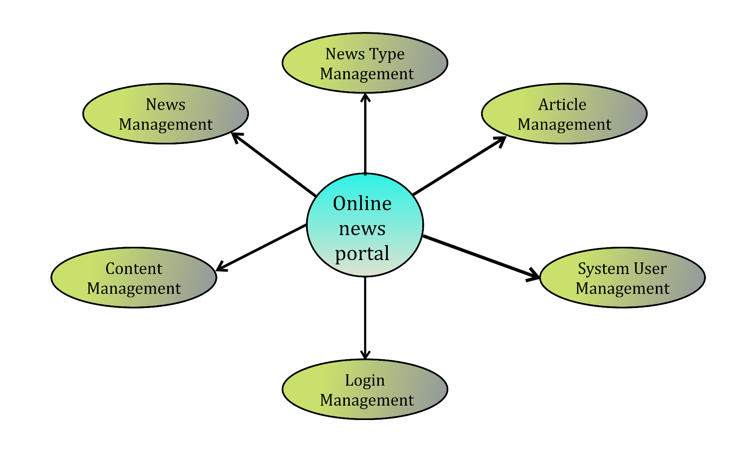

**User Stories**

|  |  |  |  |  |  |  |
| --- | --- | --- | --- | --- | --- | --- |
| **User Type** | **Functional**  **Requirement**  **(Epic)** | **User Story Number** | **User Story / Task** | **Acceptance criteria** | **Priority** | **Release** |
| Customer  (Mobile user) | Registration | USN-1 | As a user, I can register for the application by entering email, password, and name | I can access my account dashboard | High | Sprint-1 |
|  |  | USN-2 | As a user, I will redirected to the login page | I can access the web application | High | Sprint-1 |
|  |  | USN-3 | As a user, I will register for the application through Gmail account | I can register & access the dashboard with  Username login | Low | Sprint-2 |
|  | Login | USN-4 | As a user, I can log into the application by entering Username & password | I can view all types of information through this  application | High | Sprint-1 |
|  | Dashboard | USN-1 | As a user, I can log into the application and look into my dashboard | I can Look into My Dashboard after my login | Low | Sprint-1 |
|  |  | USN-2 | As a user, I can log into the application and update my personal data | I can view the personal data which can be updated by the user | Low | Sprint-2 |
|  |  | USN-3 | As a user, I can log into the application and read news based on my filter contents | News contents are filtered based on the user needs | High | Sprint-1 |

|  |  |  |  |  |  |  |
| --- | --- | --- | --- | --- | --- | --- |
| **User Type** | **Functional**  **Requirement**  **(Epic)** | **User Story Number** | **User Story / Task** | **Acceptance criteria** | **Priority** | **Release** |
| Customer (Web user) | Login | USN-1 | As a user, I can register for the application by entering my email, password, and confirming my password through web applications such as Chrome, Firefox, Brave, etc. | I can access my account / dashboard | High | Sprint-1 |